### **Networks Fundamentals II Homework: *In a Network Far, Far Away!***

### **Mission 1**

**Issue**: Due to the DoS attack, the Empire took down the Resistance's DNS and primary email servers.

* The Resistance's network team was able to build and deploy a new DNS server and mail server.
* The new primary mail server is asltx.l.google.com and the secondary should be asltx.2.google.com.
* The Resistance (starwars.com) is able to send emails but unable to receive any.

Your mission:

* Determine and document the mail servers for starwars.com using NSLOOKUP.

sysadmin@UbuntuDesktop:~$ nslookup -type=mx starwars.com  
Server: 8.8.8.8  
Address: 8.8.8.8#53

Non-authoritative answer:  
starwars.com mail exchanger = 5 alt2.aspmx.l.google.com.  
starwars.com mail exchanger = 10 aspmx3.googlemail.com.  
starwars.com mail exchanger = 1 aspmx.l.google.com.  
starwars.com mail exchanger = 10 aspmx2.googlemail.com.  
starwars.com mail exchanger = 5 alt1.aspx.l.google.com.

* Explain why the Resistance isn't receiving any emails.  
    
  The Resistance is not receiving emails because their MX record is not set to the proper primary and secondary email servers. Should be the new servers.
* Document what a corrected DNS record should be.  
    
  starwars.com mail exchanger = 1 asltx.l.google.com  
  starwars.com mail exchanger = 5 asltx.2.google.com

### **Mission 2**

**Issue**: Now that you've addressed the mail servers, all emails are coming through. However, users are still reporting that they haven't received mail from the theforce.net alert bulletins.

* Many of the alert bulletins are being blocked or going into spam folders.
* This is probably due to the fact that theforce.net changed the IP address of their mail server to 45.23.176.21 while your network was down.
* These alerts are critical to identify pending attacks from the Empire.

Your mission:

* Determine and document the SPF for theforce.net using NSLOOKUP.  
    
  sysadmin@UbuntuDesktop:~$ nslookup -type=txt theforce.net  
  Server: 8.8.8.8  
  Address: 8.8.8.8#53

Non-authoritative answer:  
theforce.net text = "google-site-verification=XTU_We07Cux-6WCSOItl0c_WS29hzo92jPE341ckbOQ"  
theforce.net text = "v=spf1 a mx mx:smtp.secureserver.net include:aspmx.googlemail.com ip4:104.156.250.80 ip4:45.63.15.159 ip4:45.63.4.215"  
theforce.net text = "google-site-verification=ycgY7mtk2oUZMagcffhFL_Qaf8Lc9tMRkZZSuig0d6w"

* Explain why the Force's emails are going to spam.

The IP address didn’t get updated.

* Document what a corrected DNS record should be.  
  v=spf1 a mx mx:smtp.secureserver.net include:aspmx.googlemail.com ip4:104.156.250.80 ip4:45.63.15.159 ip4:45.63.4.215, ip4:45.23.176.21

### **Mission 3**

**Issue**: You have successfully resolved all email issues and the resistance can now receive alert bulletins. However, the Resistance is unable to easily read the details of alert bulletins online.

* They are supposed to be automatically redirected from their sub page of resistance.theforce.net to theforce.net.

Your mission:

* Document how a CNAME should look by viewing the CNAME of www.theforce.net using NSLOOKUP.  
  sysadmin@UbuntuDesktop:~$ nslookup -querytype+cname [www.theforce.net](http://www.theforce.net)  
  Server: 8.8.8.8  
  Address: 8.8.8.8#53  
    
  Non-authoritative answer:  
  www.theforce.net canonical name = theforce.net.  
  Name: theforce.net  
  Address: 104.156.250.80
* Explain why the sub page of resistance.theforce.net isn't redirecting to theforce.net.  
  resistance.theforce.net was not listed to redirect to theforce.net only the www.theforce.net was set to redirect
* Document what a corrected DNS record should be.  
  The CNAME should look like:  
  resistance.theforce.net  
  canonical name = theforce.net

### **Mission 4**

**Issue**: During the attack, it was determined that the Empire also took down the primary DNS server of princessleia.site.

* Fortunately, the DNS server for princessleia.site is backed up and functioning.
* However, the Resistance was unable to access this important site during the attacks and now they need you to prevent this from happening again.
* The Resistance's networking team provided you with a backup DNS server of: ns2.galaxybackup.com.

Your mission:

* Confirm the DNS records for princessleia.site.

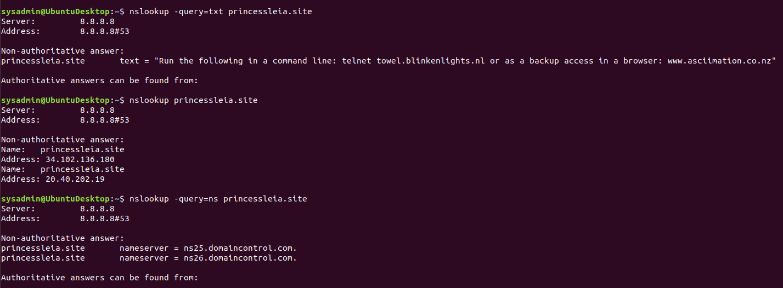

* Document how you would fix the DNS record to prevent this issue from happening again.  
    
  You would need to add ns2.galaxybackup.com

### **Mission 5**

**Issue**: The network traffic from the planet of Batuu to the planet of Jedha is very slow.

* You have been provided a network map with a list of planets connected between Batuu and Jedha.
* It has been determined that the slowness is due to the Empire attacking Planet N.

Your Mission:

* View the Galaxy Network Map and determine the OSPF shortest path from Batuu to Jedha.  
    
  D C E F J I L Q T V  
  1 2 1 1 1 1 6 4 2 2 21 hops
* Confirm your path doesn't include Planet N in its route.  
    
  Confirmed.
* Document this shortest path so it can be used by the Resistance to develop a static route to improve the traffic.

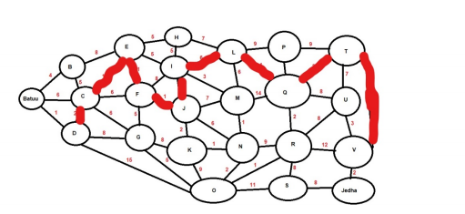

### **Mission 6**

**Issue:** Due to all these attacks, the Resistance is determined to seek revenge for the damage the Empire has caused.

* You are tasked with gathering secret information from the Dark Side network servers that can be used to launch network attacks against the Empire.
* You have captured some of the Dark Side's encrypted wireless internet traffic in the following pcap: Darkside.pcap.

Your Mission:

* Figure out the Dark Side's secret wireless key by using Aircrack-ng.  
  + Hint: This is a more challenging encrypted wireless traffic using WPA.
  + In order to decrypt, you will need to use a wordlist (-w) such as rockyou.txt.  
      
    Dictionary  
    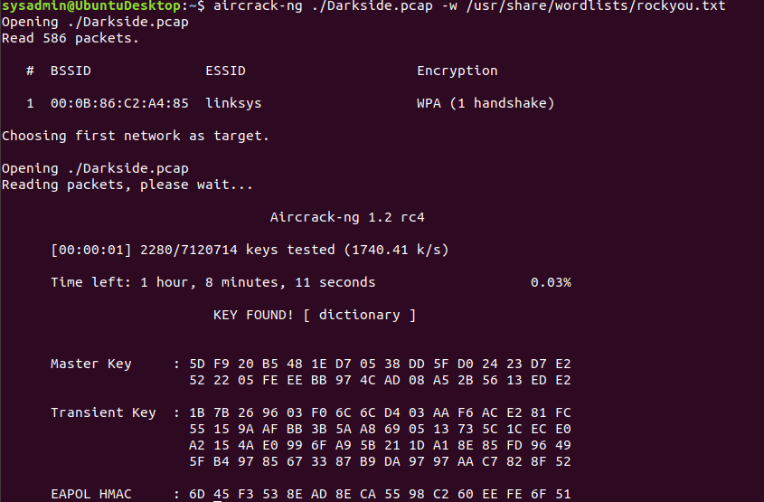
* Use the Dark Side's key to decrypt the wireless traffic in Wireshark.  
  + Hint: The format for the key to decrypt wireless is <Wireless_key>:<SSID>.  
      
    SSID: linksys
* Once you have decrypted the traffic, figure out the following Dark Side information:  
  + Host IP Addresses and MAC Addresses by looking at the decrypted ARP traffic.  
    ARP Protocol Specific Addresses:  
    172.16.0.101 is at 00:13:ce:55:98:ef  
    172.16.0.1 is at 00:0f:66:e3:e4:01

Additional IPs of interest:  
172.16.0.9 is at 00:14:bf:0f:03:30  
68.9.16.30 is at 00:0f:66:e3:e4:01 same mac as  
68.9.16.25 is at 00:0f:66:e3:e4:01 same mac as 172.16.0.1

* + Document these IP and MAC Addresses, as the resistance will use these IP addresses to launch a retaliatory attack.  
      
    172.16.0.101 is at 00:13:ce:55:98:ef  
    172.16.0.1 is at 00:0f:66:e3:e4:01  
      
    Watch gateway:  
    172.16.0.9 is at 00:14:bf:0f:03:30  
    Location: http://172.16.0.9:5431/dyndev/uuid:0014-bf0f-0330000099dc\r\n

### **Mission 7**

As a thank you for saving the galaxy, the Resistance wants to send you a secret message!

Your Mission:

* View the DNS record from Mission #4.
* The Resistance provided you with a hidden message in the TXT record, with several steps to follow.
* Follow the steps from the TXT record.  
  + **Note**: A backup option is provided in the TXT record (as a website) in case the main telnet site is unavailable
* Take a screen shot of the results.

